Using a Nipple Shield
A nipple shield can be an effective tool for assisting an infant who may have difficulty latching. This could be due to prematurity, physical characteristics of the baby, or the nursing parent’s anatomy. A nipple shield is thin piece of silicon that adds extension to the nipple and helps a baby latch on easier. Because the nipple shield is a barrier between mother and baby, it is important to use the shield correctly and to understand the possible outcomes of using a nipple shield.
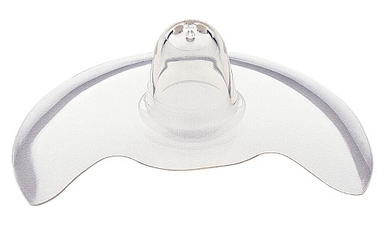
Getting Started:
- Attempt every feeding without the shield first then use if not successful.
- Place the nipple shield in hot water for a couple seconds to make it more pliable and adhere to the breast better. If needed, you can apply extra virgin olive oil or nipple cream on the rim of the shield to help with adherence.
- Flip the tip of the shield halfway inside out and place it over your nipple. Stretch it until if flips back out and suctions your nipple slightly inside.
- Massage the breast thoroughly using gentle strokes, shakes, and jiggles. Hand express milk into the shield. Stroke your baby nose and lips with the shield. Wait for your baby to open widely before pulling them in to latch. Latch as deeply as you would normally (nose tip, cheeks, and chin touching the breast). This can take a few attempts before the baby starts to suckle.
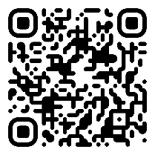
Scan the QR code for a video about using a nipple shield.

During Feedings:
- Good positioning and latch are very important when using a nipple shield. If your latch is too shallow, the tip of the shield will not reach far enough into the baby’s mouth to trigger active sucking and your baby will not be able to remove milk from the breasts sufficiently, leading to a drop a milk supply/possible breast infection as well as infant burning calories causing potential weight loss.
- Listen carefully for audible swallowing and continue to check the latch during the feeding. At least once, break the latch and ensure there is milk in the shield.
After Feeding:
- Check the nipple shield to make sure there is milk in it.
- Check your breast to make sure it has softened during feeding.
- Wash the nipple shield with hot, soapy water. Follow with a cold rinse then air dry.
- The shield is reusable unless it is torn or damaged.
- You may want to pump after feedings to ensure a good milk supply and emptying of the breasts.
Important Points:
- Continue to monitor infant’s urine and stool output while using the nipple shield. Notify your lactation consultant or health care provider if output decreases.
- Using a nipple shield has the potential to decrease a mother’s milk supply. To lessen the chance of this, pump after breastfeeding to help remove remaining milk and empty the breasts.
- Follow-up with your lactation consultant or health care provider to monitor appropriate weight gain while using the nipple shield and always bring it to your office visits in case you need to use it for a feed.
- Weaning from a nipple shield can take time and patience. Contact your lactation consultant for tips to wean from the shield.
Cornerstone Lactation
Savannah Pressley, BS, MS, IBCLC
www.cornerstonepediatrics.org (919) 460-0993

