2024-2025 Flu Vaccination Consent Form

(Please fill out one information sheet per child)

Patient’s Name: Patient’s Date of Birth:
(Child’s) (Child’s)

Has this child ever been seen by one of our Providers before? Yes No

If not, please schedule a well child check with one of our providers within two weeks of receiving flu vaccine.

Has the patient ever had the seasonal flu vaccine before? Yes No

If not and less than 9 years old, it is recommended to get 2 doses of the flu vaccine this year at least 4 weeks apart.

Has the patient had a fever within the last 24 hours? Yes No

If yes, we recommend rescheduling the vaccine to a different date.

Is the patient severely allergic to eggs? Yes No Gelatin? Yes No
If yes, please call the office 919.460.0993 and speak with a Triage nurse to discuss your options.

Has your child ever had Guillain-Barré Syndrome (a type of temporary severe Yes No
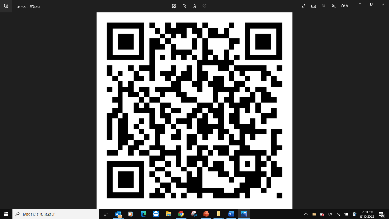
muscle weakness) within 6 weeks after receiving a flu vaccine?

By my signature below, I acknowledge access to the 2024-2025 Influenza Vaccine fact sheet QR Code (presented to the right). I understand the benefits and the risks of the vaccine, and I am authorizing a qualified member of the Cornerstone Pediatric & Adolescent Medicine staff to administer the Influenza vaccine according to the guidelines set by the Centers for Disease Control and Prevention.

Parent / Legal Guardian / Patient Signature: _______________________________________ Date: ____________________

(If 18 years of age or older)

Relationship to Patient: ________________________
(If patient is under the age of 18 the signature of a parent or legal guardian must be obtained)

For Office Use Only

Private Insurance Medicaid No Insurance
Private Vaccine Given State Vaccine Given **Always use state funded vaccine for patients with Medicaid or no insurance**

 | 90656 – Fluarix = 6 months of age and older |  | 90471 – Administration of 1 Injection
 | 90656 – Fluzone=6 months of age and older

Nurse Signature: ___________________________________ Manufacturer Lot #: __________ Exp: __________ Site: _____________

